**Battle of Neighbourhoods for Food Truck Establishment in Bangalore**

**Introduction:**

The city of Bangalore has beautifully combined its rich cultural heritage with its technological and industrial accomplishments. In fact, this blend of traditions with the modern culture has made Bangalore one of the most happening cities in India. It is also called Silicon Valley of India. With people migrating from all kinds of multicultural background of India, Bangalore has been accommodating in every aspect. In the recent past, Bangalore may have evolved into a modern city adopting a lot of western ideologies, but the people of this city have clung on to its food heritage. There has been a drastic change in the city in terms of its infrastructure, transport facilities, population etc.

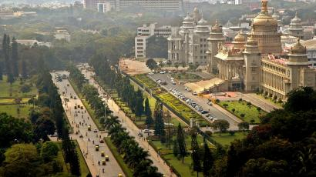

Owing to these changes, the kind of food culture that exists in the city has opened to a wide range of varieties catering to the different people hailing from different cultures. Along with the trend many people are open to trying different cuisines at different locations. There fore food catering industry has evolved into a competitive industry on a global level. Day by day many restaurants, cafes and bars are becoming innovative and creative in their form of delivery for customer satisfaction. With the recent era of “rating” this is justifiable. One of those trendy and innovative concepts is “Food Trucks”.

From the moment we invented streets, there have been street vendors. All you need is a good product, access to fire, a cart with sturdy wheels and you've got a business on your hands. Since then entrepreneurs have been investing in food trucks, carts, stands and all kinds of other mobile vending solutions. This has gradually shifted focus from ambient oriented food business which used to be so 2000’s.

**Business problem/Solution:**

The goal is to find an area to set up food truck in Bangalore. To do that I want to build my business in the centre of the other accessible and running food trucks already exist, and. I will be using K-Means to find the average location of all the food truck locations and build my store there.

Anyone who wants to open a highly competitive and affordable food truck would be interested in the data.

**Data:**

Using Foursquare and geolocator the latitudes and longitudes of Bengaluru also called as Bangalore was taken out. Now that we have the city map, the data needed to complete this task is the location of the other food truck and small stores setup which are available online. These can be accessed through the Foursquare API as taught in week 2 also using the general customer id for food truck in foursquare for easy processing of data. The data I call from the API will the name of the business, as well as the latitude and longitude of the store in a radius of 500.

### Methodology:

### *Collecting the list of wards*: Using the panda libraries, the list of wards(areas ) were obtained from the Wikipedia page.

### *Using Foursquare API*: The data collected from Foursquare were the location, name and type of the food truck stores in and around Bangalore. I used a radius of five kilometres centred on 12.9791198 and 77.5912997 by calling the Foursquare API. Using the function getnearbyfoodtrucks , the following information was extracted:

* Venue ID
* Venue name
* Latitude
* Longitude
* Venue Type

A map was plotted showing the available food truck locations using a folium map. To remove the duplicated results, drop_duplicates was used and then replotted.

Later K-means clustering algorithm was used for the analysis, In this study, using K-Means, with a k value of 1, the average of all the food truck locations were found .Then by Calling the cluster centers function the local minimum of distance to every point was pin pointed . This was done because K-Means is an effective and efficient method of finding this kind of information.

**Results:**

Through the use of K-means, the most competitive location was found to be 12.970270757274333, 77.58924823681946 as marked in red in the map.

The location is ideal as it is been surrounded by the most famous Cubbon park, Kanteerava stadium and St.John’s College of Bangalore.

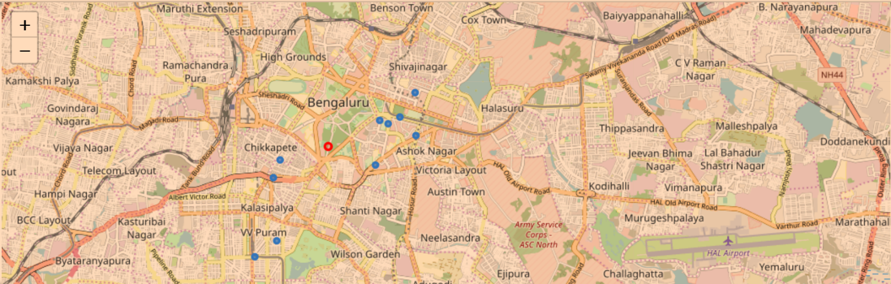

**Discussion and Conclusion:**

On this notebook, analysis of best location for establishing food truck spot based on the available food truck category has been presented.

Using Foursquare API, a good amount of possible venues was considered. Sourcing from the Foursquare has its limitations. Therefore, the list is not an exhaustive list of available venues. Also, the generated venue obtained from the analysis is very interesting as it is been surrounded by various Tech companies and colleges, who will be the possible major customers for the food truck.

Furthermore analysis can be done based on the cuisines and population in the area considered.